Classroom Projects and Discussion Questions for The Books of Elsewhere: The Shadows
by Jacqueline West

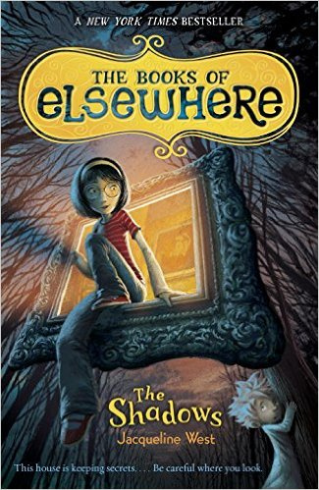

Projects using THE BOOKS OF ELSEWHERE
- Build a diorama of a room in the old stone house on Linden Street (– or build the house itself!).
- Create a painting that you would climb into if you had Olive's spectacles.
- Using an art book (or a visit to an art museum), choose a favorite painting. Write a story describing what would happen if you climbed into that painting.
- Research the history of the town, neighborhood, or street that where you live. If you met someone like Morton, who had lived there a hundred years ago, how would his version of your town/neighborhood/street be different from your version? What things have changed? What has stayed the same? Write about/present your findings.
- Turn a favorite scene from the book into a play or a puppet show.
- Create and illustrate a map of Olive's house or street, identifying important locations.
Level One Discussion Questions
- What are Olive's parents' professions?
- What are some of Olive's interests or hobbies?
- There are three cats living in the old stone house. What are their names?
- What painting does Olive climb into first?
- How does Olive get into the attic?
Level Two Discussion Questions
- Why has it been hard for Olive to make or keep friends?
- Why does Olive trust Annabelle – at least at first?
- How does each cat suit the place he guards?
- Identify one simile and one metaphor that you think are especially vivid. How do these help you picture the action within the story?
- What are some other ways Olive might be able to defeat a living painting like Annabelle or Aldous?
Level Three Discussion/Writing Questions
- How might Olive's life be different if she had a brother or sister?
- Why do you think some children turn out to be very different from their parents? How are you different from your parents? How are you the same?
- Which painting in Olive's house would you explore, and why?
- Do you think someone who has worked for an evil boss or master—like the cats, who worked for the McMartins—should be blamed for the bad things that the master asked them to do? Why or why not? Can you think of some real world examples where this has happened?
- If Olive and her parents stay in the old stone house on Linden Street, what else do you think might happen?



